# **LED Wallee**

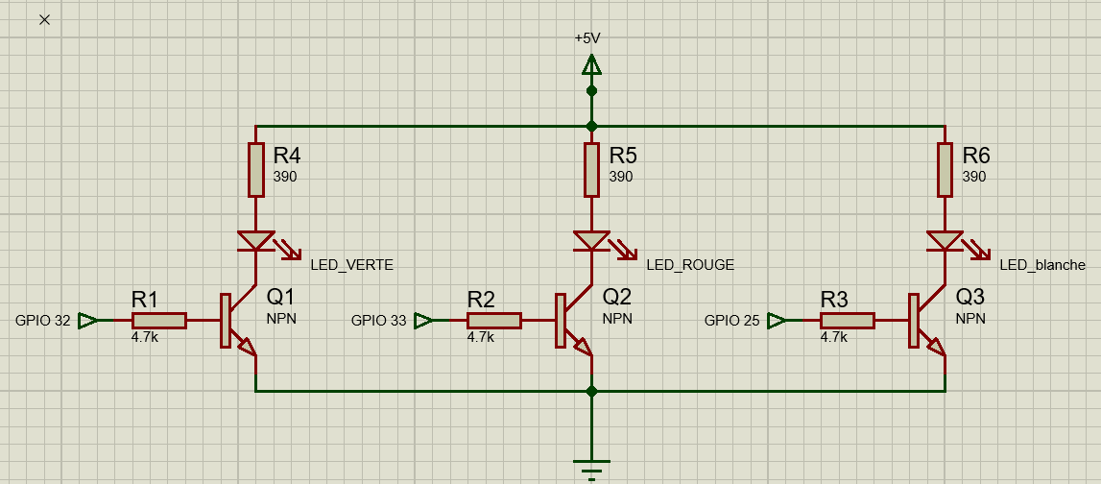

|  |  |
| --- | --- |
| 1. **led_verte** | **32(ESP)** |
| 1. **led_rouge** | **33(ESP)** |
| 1. **led_blanche** | **25(ESP)** |